**What is Software Engineering?**

NO RETAKE  
NO SMOKING

Software engineering is the application of principles used in the field of engineering, which usually deals with physical systems, to the design, development, testing, deployment and management of software systems.

**2. Why is the Waterfall method described as a plan-driven development methodology? (2 points)**  
The waterfall model is mostly used for large systems engineering projects where a system is developed at several sites. In those circumstances, **the plan-driven nature of the waterfall model helps coordinate the work**.  
The cost of accommodating changing customer requirements is reduced.  
There are another reasons:  
1.Requirements are clear and fixed that may not change.

2.There are no ambiguous requirements (no confusion).

3.It is good to use this model when the technology is well understood.

4.The project is short and cast is low.

5.Risk is zero or minimum.

**3. What do you think that some companies opening software product beta testing public? (2 points)**   
Through beta testing, **you're able to expand on any usability studies your team has previously done in a lab and see how your product is performing out in the wild**. This can provide valuable feedback that will allow you to make some final improvements before release.

**4. What is the most commonly used V&V activity in testing? (2 points)**

In software project management, software testing, and software engineering, verification and validation (V&V) is the process of checking that a software system meets specifications and requirements so that it fulfills its intended purpose. It may also be referred to as software quality control.  
**There are two aspects of V&V (Verification & Validation) tasks:**  
Confirms to requirements (Producer view of quality)  
Fit for use (consumers view of quality)

**5. What is the difference between Functional Requirements and Non-Functional Requirements? (2 points)**

**Functional** requirements explain how the system must work, while **Non-functional** requirements explain how the system should perform.

**6. What are the advantages of Test-driven development in Software Engineering? (2 points)**By starting tests with the simplest functionality first, you can use them to guide your logic as you build up functionality. This helps you to break a problem down into smaller, more manageable pieces, thus aiding the problem-solving process.  
other benefits of TDD:  
1. Code coverage  
2. Regression testing  
3. Simplified debugging  
4. System documentation

**7. What is the main difference between Requirement Elicitation and Requirements Specification? (2 points)**   
**Requirements Elicitation** = Requirements Gathering. This is asking what the requirements are, what if this, what if that, etc. This is about asking the questions and getting responses. How well are the answers being another matter entirely? This requires the stakeholders to answer their part of what is to be done and why.  
**Requirements Analysis.** This is more the organizing of answers to the first part. Which solution is optimal? What are the trade-offs of various possible implementations? In this part there may be the odd question, but it isn't the main point as this is about seeing which solution may be better under various constraints, e.g. which is the fastest or cheapest. This is more about how something is to be done and why does that way make more sense than another. Изображение выглядит как текст
**8. What are Software Design Patterns? (2 points)**

Patterns are a way of reusing the knowledge and experience of other designers. Design patterns are usually associated with object-oriented design. Published patterns often rely on object characteristics such as inheritance and polymorphism to provide generality

**9. Why is the scrum (agile) method convenient in modern software engineering? (2 points)**

What is Agile software development?

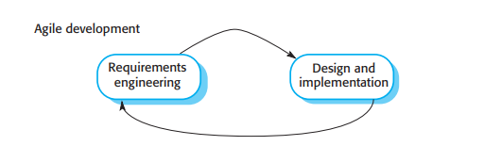

Agile methods are incremental development methods in which the increments are small, and, typically, new releases of the system are created and made available to customers every two or three weeks. They involve customers in the development process to get rapid feedback on changing requirements. They minimize documentation by using informal communications rather than formal meetings with written documents.

**10. What is the difference between Release testing & User testing? (2 points)   
Release testing:** a separate testing team test a complete version of the system before it is released to users.   
**User testing:** users or potential users of a system test the system in their own environment.

**11. What kind of methods/activities are there in Requirements Elicitation? (2 points)   
НО есть еще в инете варики  
**

**12. How do companies get benefits and earn money from open-source software solutions? (2 points)   
 Here are six methods you can employ:**

* Paid support
* Software as a Service (OpenSaaS)
* Open-core model
* GitHub sponsors
* Paid feature requests
* Get paid to build open source extensions for existing products

**13. Why is the Activity Diagram widely used between software developers and non-software developers (salespeople, logistics people, finance people, etc)? (2 points)**However, the diagrams are a useful and effective modelling tool that can be used throughout the system development process. They **help to visualize the functionality of the system at different levels of detail, and aid communication between developers and clients**.

**14. Please draw UML diagrams to describe WSP (University-based information exchange application) (2 points)**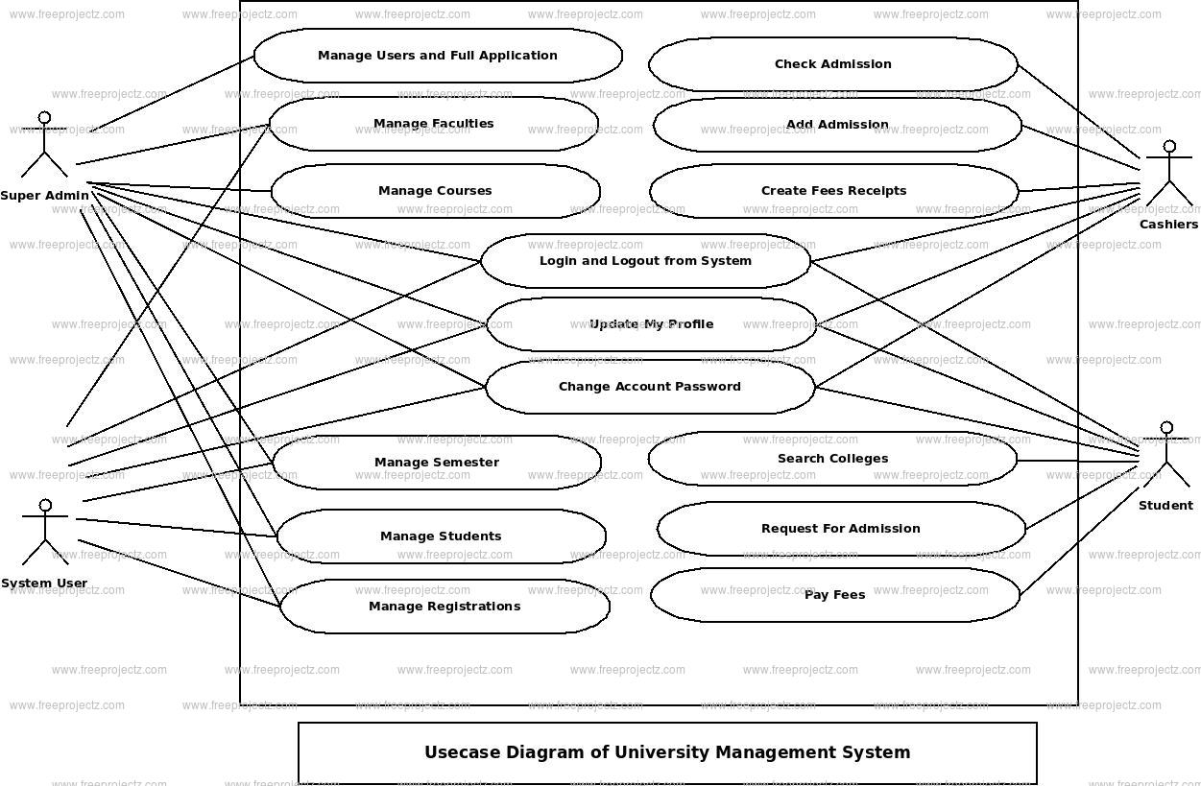

**15. Where do we use State Machine Diagrams? (2 points)**State machine diagrams are **usually applied to objects but can be applied to any element that has behavior to other entities such as: actors, use cases, methods, subsystems systems and etc**. and they are typically used in conjunction with interaction diagrams (usually sequence diagrams)

**16. What is the availability of the principal dependability properties of software engineering?   
**

**17. What is the 4 + 1 view model of software architecture? (2 points)**

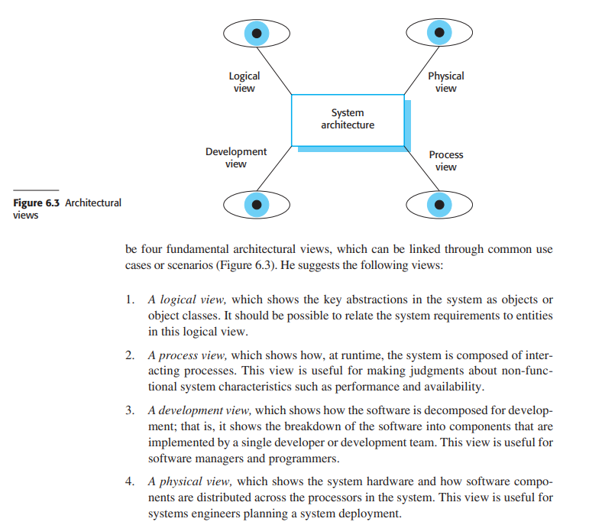

**18. What are Context models in System Modelling? (2 points)**A Software System Context Model is **a type of system context model that explicitly depicts the boundary between the software system and its external environment**: the hardware devices that the software system interacts with in order to engage with the environment

**19. Why do you think that modern software operation system turns off automatically when processors heat up (at a higher temperature than the allowed temperature)? What are the principles behind this dependability property? (2 points)**Computers need to be cooled down and maintain certain temperatures to run optimally. Thus, when a PC is running at extremely high temperatures (above 60℃), it will shut down **to protect its components from further damage**.  
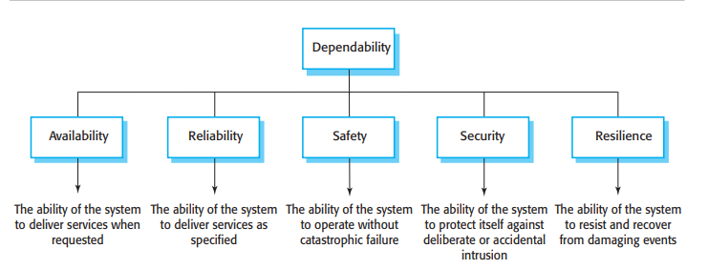

**20. Please describe how GitHub helps software developers (2 points)** GitHub **allows developers to change, adapt and improve software from its public repositories for free**, but it charges for private repositories, offering various paid plans. Each public or private repository contains all of a project's files, as well as each file's revision history.

**ADDITIONAL QUESTIONS**

**What is the difference between alpha and beta testing?**

**What kind of processes are there in Software Testing?**

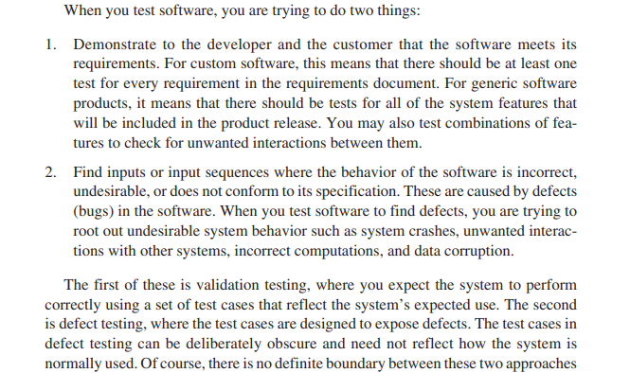

**What are Product Requirements?**

**Why do some companies like Apple pay more attention to System Modeling for their products?**

Models are used during the requirements engineering process to help derive the detailed requirements for a system, during the design process to describe the system to engineers implementing the system, and after implementation to document the system’s structure and operation.

**What is the Context model in System Modeling?**

**Why is Test-Driven Development convenient in the modern software engineering field?**

Test-driven development is of most value in new software development where the functionality is either implemented in new code or by using components from standard libraries. If you are reusing large code components or legacy systems, then you need to write tests for these systems as a whole. You cannot easily decompose them into separate testable elements. Test-driven development is now a widely used and mainstream approach to software testing. Most programmers who have adopted this approach are happy with it and find it a more productive way to develop software. It is also claimed that use of TDD encourages better structuring of a program and improved code quality. However, experiments to verify this claim have been inconclusive.

**What is the difference between Functional & Non-Functional Requirements?**

**Functional requirements explain how the system must work, while non functional requirements explain how the system should perform**.

**What is the Ethnography in Requirement Elicitation?**

Ethnography is helpful to understand existing systems, but this understanding does not always help with innovation. Innovation is particularly relevant for new product development. Commentators have suggested that Nokia used ethnography to discover how people used their phones and developed new phone models on that basis; Apple, on the other hand, ignored current use and revolutionized the mobile phone industry with the introduction of the iPhone.

**How do companies get the benefit and earn money by providing open-source software solutions?**

